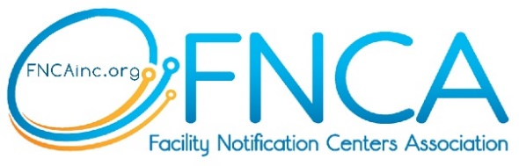 | MEMBERSHIP AGREEMENT

Centers Information
Name of Center: |  |  |  | Type: | Select One
Services at this Center (check all that apply):
☐ Locate Request Processing | ☐ Quality Assurance
☐ Damage Prevention Education | ☐ New Employee Training
☐ Damage Prevention Awareness | ☐ HR
☐ Pipeline Awareness Outreach | ☐ Finance
☐ Marketing & Media | ☐ IT / Technology Services
☐ Member Services | ☐ Other: Click or tap here to enter text.
☐ GIS-Mapping | ☐ Other: Click or tap here to enter text.
CEO/ED/President:
 |  | First Name |  |  | Last Name Title
Email/Phone:
 |  | Preferred Email |  |  | Primary Phone
Billing Address:
 | Address City |  |  |  |  | State |  |  |  | ZIP Code

Billing Phone: |  | Email

Alternate Contact to CEO/ED/President
Full Name: |  | Phone:
Title:
Email:

Terms of Membership

Annual Meeting of the Membership shall be held at the Fall Conference each year unless another time is approved by the board. Membership dues must be paid promptly to participate in association offerings. Member may cancel their membership by written notice on or before July 1st giving notice that the member shall cease their membership on December 31st of that year. Member organizations and those involved in activities are to abide by the bylaws and operating procedures of FNCA. Note: bylaws can be found at FNCA Bylaws.

Signature: |  | Date:
of CEO/ED/President
Last Updated: 3.19.2025

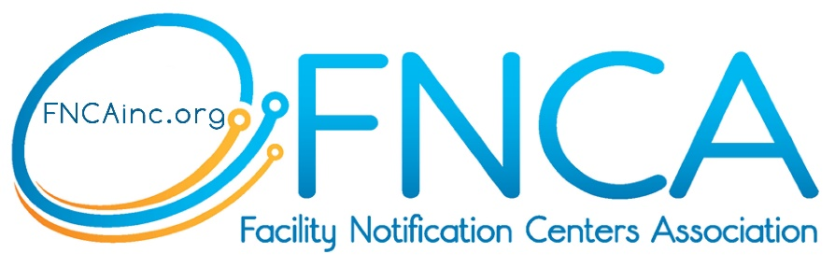
AGREEMENT & BENEFITS OF MEMBERSHIP
VALUES, MISSION & VISION

- $2,500 – Annual Membership Fee (US Dollars)

- Provide a place for facility notification centers to work on continuous improvement of underground utility safety, working in concert to resolve, for the benefit of all, our common issues;
- Represent the perspectives, needs and opinions of the facility notification centers and their damage prevention systems;
- Advance opportunities to share knowledge and resources to address challenges and capitalize on opportunities, achieving the highest levels of performance possible in the most cost-effective way;
- Drive innovation for facility notification centers stakeholders in the damage prevention industry;
- Foster damage prevention that aides in cost reduction for its members, and provides valuable tools and ideas that create consistency across facility notification centers;
- Offer a forum to discuss issues facing the facility notification centers. Share information with all centers and organize discussions to get our industry on the same page as much as possible; and,
- Provide a resource or repository for keeping, sharing & expanding the knowledge & experience gleaned from facility notification centers operators.

FNCA’s stated mission is “To evolve our industry by facilitating collaboration among facility notification centers.” Stakeholders include facility notification centers, center executive leadership and center staff.

Our (9) core values are:
- Collaboration of ideas, best practices, lessons learned, etc.
- Safety/damage prevention
- Value to stakeholders
- Mutual respect
- Foster Trust
- Time
- Commitment
- Transparency
- Varied perspectives

The vision for the organization is to be an education-based association, expanding upon value-added services including networking forums for executive leaders and functional staff, in-person, and video conferencing, virtual education, training on a broad array of topics (from leadership development, board development and succession planning to IT assessments, cybersecurity, and disaster recovery), and the development and maintenance of a member resource and data library.

Last Updated: 3.19.2025

